Self-Guided Family Resources

The Brief
We are looking for a creative practitioner to create a self-guided experience for family visitors to the Brunel Museum on site at the Museum during school holidays. This could be in the form of a paper-based or other material trail, a series of interventions that can be introduced and removed from the Museum site when required or a digital resource.
We are looking for an experience which will drive family visits to the Brunel Museum. We are looking for a sustainable activity that can be run again and again without significant additional input from the Museum (please see considerations below). We would be looking to launch the activity during the Easter holidays (see timeline below).

The Brunel Museum
The Brunel Museum is a much-loved local landmark, attracting 35,000 people annually through walking tours, school trips, events and our museum exhibition. The museum displays are housed within the engine house, which is a Scheduled Monument. This is due to its role as ‘an integral part of the first Thames Tunnel, a remarkable feat of engineering as the first sub-aqueous tunnel under the River Thames’.

The Museum site consists of the Grade II* listed Tunnel Shaft which is accessible by a staircase. The bulk of the collection consists of Thames Tunnel souvenirs and ephemera, which are on display in the nearby Engine House. This is where the Museum’s reception and toilet facilities are. The site is encompassed by a piazza, which has a number of benches in the shape of Brunel Monuments.
See Appendix 1 for Further information about the Museum.

The Experience
We are looking for experiences that are both cost effective to produce and/or can be easily replaced. This might look like paper trails and props that can be recycled and reprinted with new content, or reuseable props that are stored on site and brought out as needed. The Museum has very limited storage so consideration should be given to where any additional items produced would be stored on site. This could also be a digital trail or have filmed elements (please see assets below).
The experience should be something that families can do together. Further information about our definition of ‘family’ and target age ranges are given below.
Consideration should be given to how robust or hardwearing the materials needed are, especially with a family audience.
We would like there to be a ‘shareable moment’ at some point during the experience. This might include a ‘selfie’ moment or something that can be shared on social media. Consideration should be given to how the Museum can share this.
You may wish to consider producing something families can take home with them, but this is not crucial. If so, please indicate the ongoing cost of production.

Target Audience
Our definition of a family is an intergenerational groups of at least 1 adult and 1 child. We are targeting children between 7 and 11, but also recognize that family groups may have older or younger children within them and this should be considered and reflected in your proposal.

Existing assets
The Museum has some existing assets we can make available for use in the development of this project:
- High resolution collection images (See below)
- High resolution images of the Thames Tunnel Archive
- A television screen (For example this could be used for a pre-activity briefing to reduce ongoing staff costs. Please indicate if you intend you use this in your activity, and note the section on fees)
- A projector in the Grade II* listed Tunnel Shaft
- Tablets. The Museum has a small number of tablets that could be made available for this activity.
The Museum also has two existing paper trails which are included with this pack.

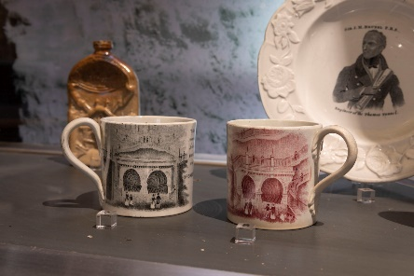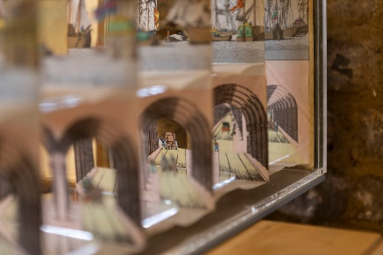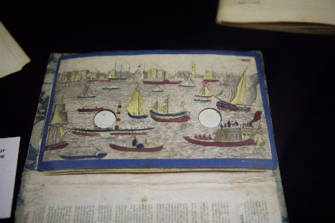
Fig 1. Images of the Collection can be made availabel. Find out more: Collection - Brunel Museum (thebrunelmuseum.com)

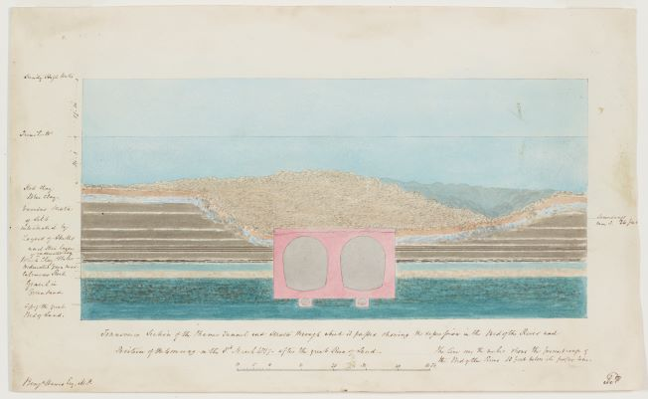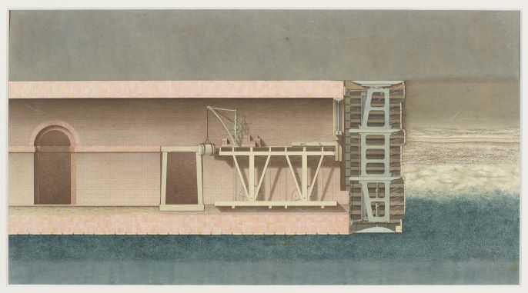
Fig 2. Images form the Thames Tunnel Archive: Thames Tunnel Archive - Brunel Museum (thebrunelmuseum.com) The Thames Tunnel Archive - Part 1/5
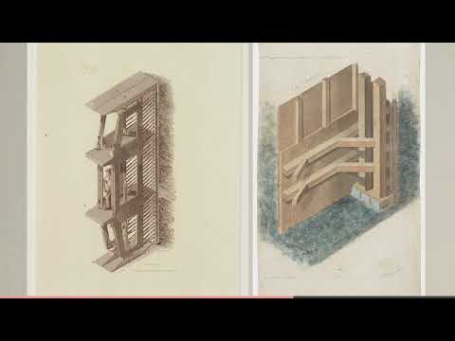
Who should apply:
We welcome approaches from more than one individual working together (for example a learning practitioner and a graphic designer may wish to put in a joint proposal). Alternatively, you may wish to apply as an individual and procure the services of others using the budget available.

The Budget
We have £3, 000 available for this project, which we intend to pay over 3 installments of £1k. The payment schedule is as follows:
w/c 31 January | 1st invoice | £1000
w/c 28 February | 2nd invoice | £1000
w/c 21 March | 3rd Invoice | £1000

Please outline how you would spend the money including:
- Development fees
- Creation of product (including fees for actors if filmed or animators)
- Materials
- Replacement for materials
- Any facilitation costs

Please also include a day rate for a future Service Level agreement.

Fees
If you are paying actors, we expect equity rates. We expect any subcontratcors to be paid a fair wage. For further details, please see the following website:
Living Wage Foundation: https://www.livingwage.org.uk/what-real-living-wage
Equity rates: https://www.equity.org.uk/at-work/list-of-rates-and-agreements/
The Proposal
Please provide:
-An overview of your innvovative approach
-An outline of the activity itself, showing how you have considered the needs of the audiences and the history of the site
-Samples of similar work (including images, testimonials)
-An outline budget
-A proposal for testing content with audiences during February half-term

We would recommend anyone wishing to submit a proposal book in a site visit. The Museum is open to the public Saturday and Sunday, 11am to 3.30pm. If you’d like to visit outside of these times, please email hello@thebrunelmuseum with the subject line ‘Family Learning Site Visit’. We will pay travel expenses up to £25 for site visits ahead of submitting a proposal.

If you have any questions, please do get in touch with Katherine McAlpine on katherine.mcalpine@thebrunelmuseum.com (Please note Katherine is not available Thursday 20 to Monday 24 January incluisve).
Deadline: 9am, Tuesday 25 January

Timeline
W/c 10 Jan and w/c 17 Jan–Available for site visits
9am Tuesday 25 January – Deadline for proposals
w/c 31 Jan - Appoint tender and 1st invoice
w/c 7 February – Prototype/1st iteration delivered
w/c 14 February – Testing with families
w/c 28 February – 2nd Invoice
w/c 14 March - final snagging
W/c 21 March -Delivery and 3rd Invoice
W/c 28 March - laucnh of activity

Appendix 1 – About the Brunel Museum

In 2017, the museum acquired at auction a pre-eminent collection of Brunel watercolour designs of the 1843 Thames Tunnel, which require appropriate display in the engine house through this project.

The adjacent tunnel shaft, as part of the Thames Tunnel, is listed at Grade II*. In 2016, the 15-metre deep tunnel shaft opened as a flexible space for performance, events and activities through the installation of a new staircase and entrance. These events are inspired by the historic use of the tunnel shaft (or Grand Entrance Hall as it was originally known) as an entertainment venue hosting concerts, banquets and fairs.

A tranquil garden space sits on top of the tunnel shaft, hosting regular Midnight Apothecary cocktail events. A pleasant piazza space is home to a series of herb planters and permanent benches designed in the shape of bridges, representing significant bridges designed by the Brunel family.

An open space with views of the River Thames is diagonally opposite the piazza, providing a nice visual connection to the river and tunnel running below.

The tunnel shaft and the outdoor spaces are highly valued by the local community.

The site is of international heritage significance due to its structures and direct connections with the groundbreaking achievements of the world-famous Brunel family.

The museum’s mission is: To preserve and share widely the ground-breaking stories of the Thames Tunnel project and the outstanding achievements of the Brunel family and their relevance to our lives today. We inspire communities through exploration, learning and performance

Appendix 2 – Timeline of key events

1825 March – Work begins on the shaft at Rotherhithe. Boring of tunnel begins in November.
1827 May – Miners working on the tunnel protest over wages. First major flood occurs
1828 January – Second major flood. Six men are killed and Ismabard is injured.
1828 August – Tunnel is bricked up following financial difficulties. The tunnel is closed for 7 years.
1835 March – Tunneling restarts
1841 November – Tunnel reaches Wapping
1843 March – Thames Tunnel opens to pedestrians
1852 – first Thames Fancy Fair is held in the tunnel
1865 – Tunnel handed over to East London Railway
1869 – First East London line train goes through the Thames Tunnel

