# 

# 🧭 Social Story: My Visit to the Brunel Museum

This story is for anyone who likes to prepare for a visit to a new place. It is especially designed for neurodivergent visitors, including those on the autism spectrum.  
  
This visual story will tell you about:  
- How to get around the museum  
- Who you might meet  
- The sounds, lights, and smells of the museum  
  
If you have any questions before your visit or would like to arrange a familiarisation visit, please contact us.

## 1. Before I Go

I am going to visit a place called The Brunel Museum.  
It is in London and tells the story of a tunnel under the River Thames.  
I can go with someone I know, like a friend, family member, or carer.

## 2. Arriving at the Museum

When I arrive, I will see a red-bricked building, set back from the road.  
I cross a courtyard to reach the door to the museum. It may be busy or quiet.  
The door is on the side of the building.

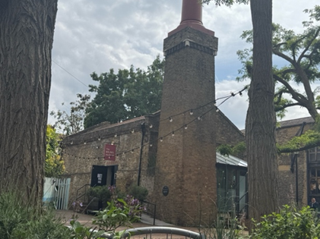

💡 The entrance is naturally lit, but the inside may be a little dimmer.  
  
I will go through the front door to the reception and gift shop. The gift shop displays a wide range of books and Brunel-themed merchandise.

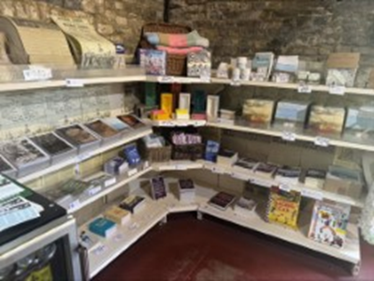  
  
There are staff behind the desk where I can buy a ticket. If I need help, I can ask them. They are very friendly.

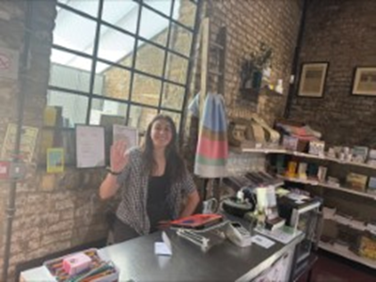  
  
The staff are here to help me. I can ask questions like:  
- “What is this?”  
- “Can I go in there?”  
- “Is it noisy inside?”

The toilets are down the stairs next to the gift shop.

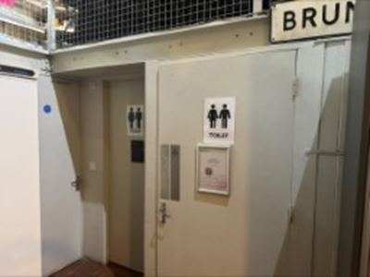

## 3. Inside the Museum

The museum has several sections.  
  
🛠 The Engine House   
This is up the stairs next to the gift shop. In this section, there are many things to see:

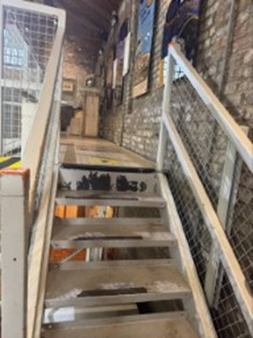  
- A short film I can listen to using headphones  
- Display cases with items like Brunel’s buckles  
- QR codes to find out more about objects  
- Interactive displays

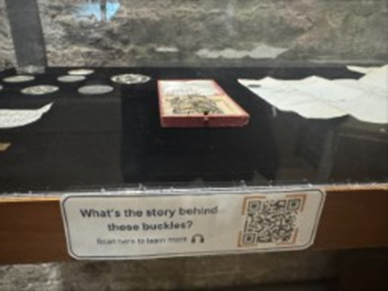  
  
The Engine House may have sound effects or voices from the film.  
💡 Lights are generally soft,   
📱 Some QR codes play audio

## 4. The Tunnel Shaft

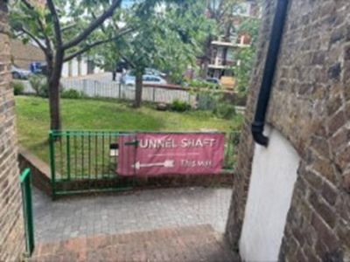

This part is underground. There are stairs to go down into the shaft.  
If I do not want to go down, that is okay.

Please note: visitors may hear loud noises in the Shaft, including trains passing overhead and the sound of the pump. These noises can echo and may be surprising or uncomfortable for some visitors.

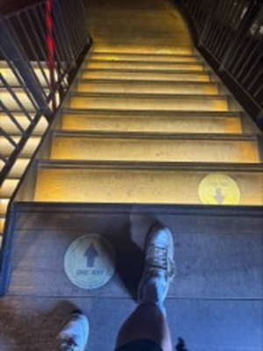  
  
There is a short film that tells me more about the museum.

The film is subtitled.

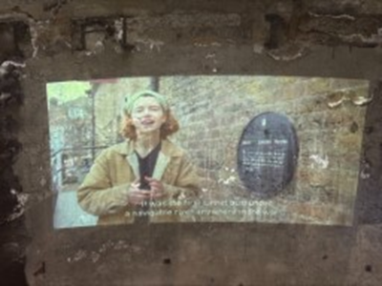

I can watch the film from the top of the stairs if I prefer.

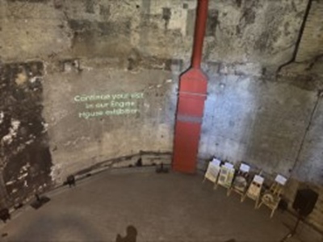  
  
It may feel colder or darker in the shaft.  
  
👂 There might be background sounds from the film.  
💡 The lighting is low. Some people may find it too dark.  
🌬 It might feel damp or chilly underground.

## 5. Taking a Break

There is a garden outside the Tunnel Shaft. It has trees, flowers, and benches to sit on.  
I can go there if I need a break or want some quiet.  
I can also have a drink or snack there if I want.

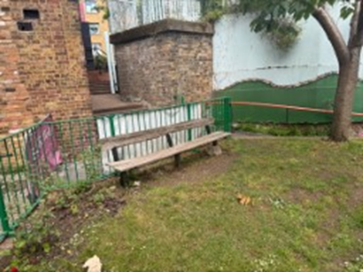  
  
👂 You may hear birds or street sounds from nearby.  
👃 It might smell of flowers or grass.  
🌞 It can be bright or shaded depending on the weather.

## 6. Leaving the Museum

When I am ready to leave, I can go through the front door or visit the shop.  
It’s okay if I didn’t see everything. I can come back another time.

## 7. Things to Remember

🟢 I can go at my own pace  
🔇 I can take a break any time  
🗺 I can ask for a map or help  
😊 I can enjoy learning in my own way

